CRM 7 Walkthrough Part 5 Minutes
4.17.2026 |  | 10:00AM – 11:00AM CST
Team | Customer
Facilitators | Jose, Dawn,
Note taker | Taylor
Attendees | Jose, Dawn, Tara, Shibu, Nammi, Mohanta, Ajaya, Shibbu, Balajit
Notes:
ORDER MANAGEMENT
- Don’t serve electric in the city of Howell
- Completely Custom Screen
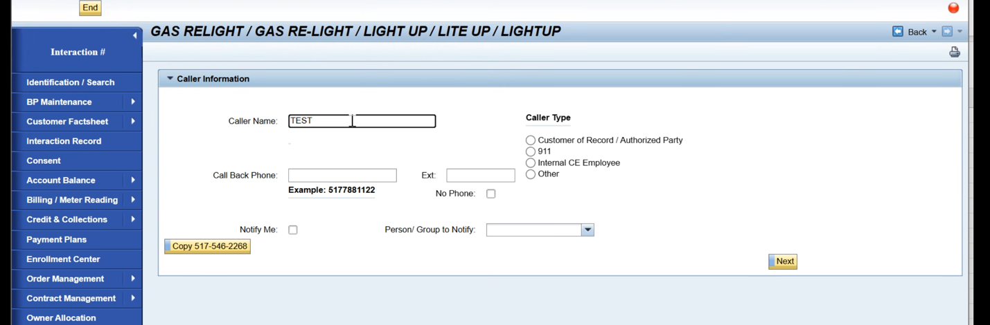

Data Source for Appointment = WAM Capacity Schedule from ECC

Does this condition quality as a hardship only Nov – March

Was the customer’s preferred relight data available: Stored Action Side of ECC Order (Follow Up with Tara)
Use Data for scheduling and capacity times
Goes into Actions tab after its created

Call Summary Completely Custom

ECC Notification shows up in ECC

Notification creates the Service Order
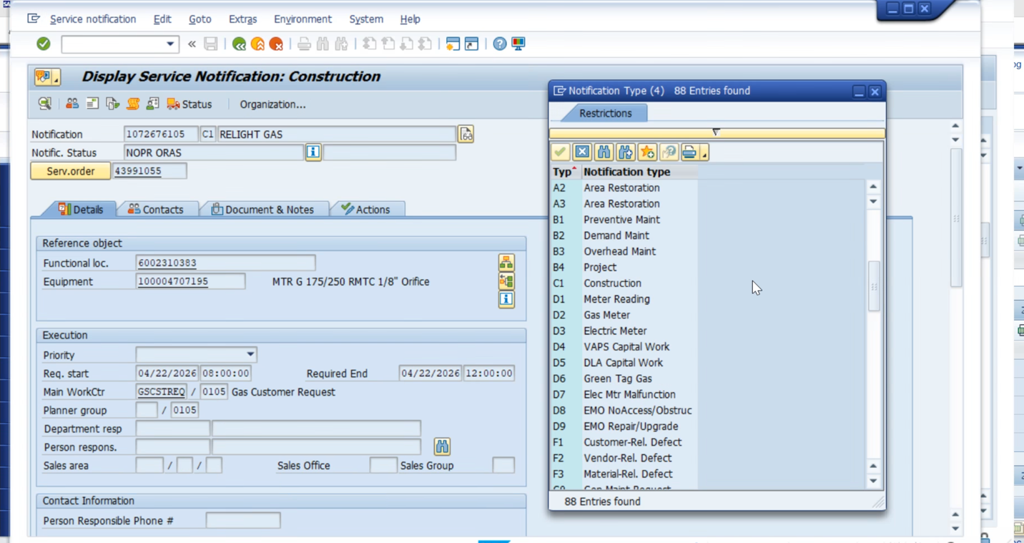

Options for Custom Screens
- Mash Up
- SAP Build

Need Decision – Build App or S/4 for Creating Service Order

Main Work Center- how they assign work to crews

Capacity buckets ECC

Create Notification in ECC, can you schedule in ECC?
Prefills and automatically selects Construction

Start with IW51and IW56 Create Service Notification with different starting points

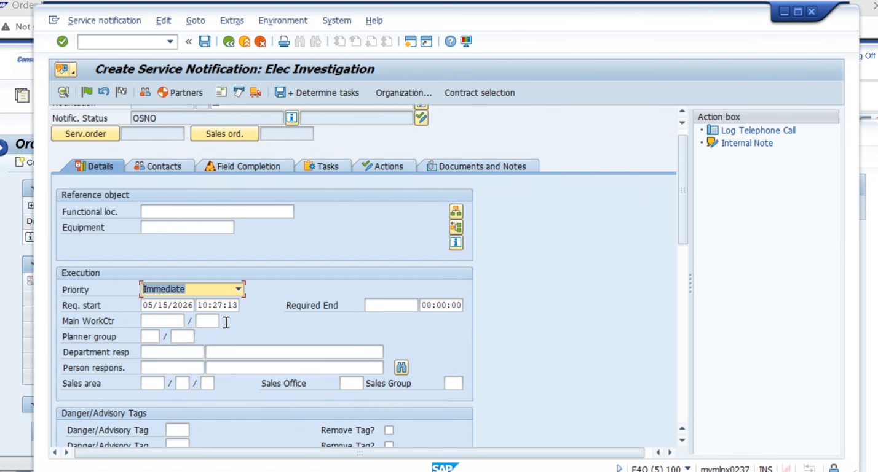

Everything has a notification, but not all notification has orders

Service Notification Key Decision

CSRs don’t create Sales Orders (Don’t use Vendor information)

Need to see SD, Sales and Distribution Docs (Goes under the BP number)

WRICEF
8mil in KAN1
7.1 in BUT
Everything missing in BUT will be created in KAN1

Business Partner Add on
Directly Migrate to ECC

Display Service Notification: Elec Investigation
Where are we going to build to logic / where the work will reside
Main Work Center populated based on the notification

CSRs have Knowledge Based Service Now Job Aids set up in Service Now
No plans to connect to workzone

Riverstar CSR sending emails directly to customer
As of now no inbound / outbound emils

Inbound / outbound emails Key Decision

Integrations through Web to PO

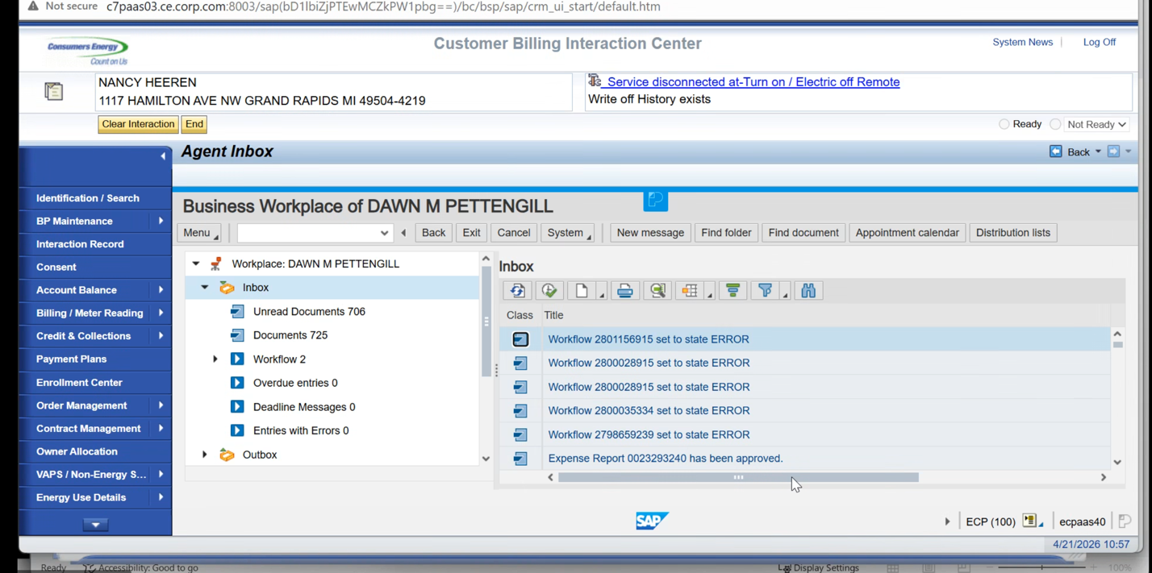

Park document Created regardless of Success or Fail

This is not in the CSR Role
The certain CSRs assigned to work can resolve Park Documents, working park documents from day before

Supervisors do Refund approvals here too

Miscellaneous
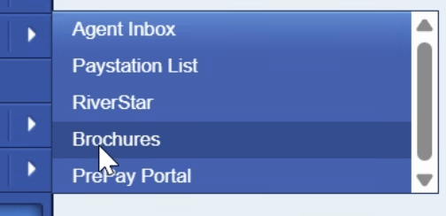

CSRs can unlock users and reset their password
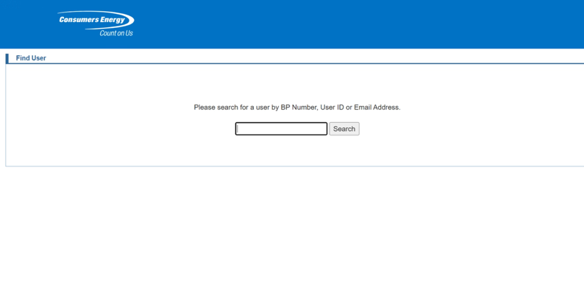

Customer Preferences
- Web Portal
- View Message History is Kubra bolt on only, takes you to a new window
- Customer data is saved in CRM to load into Kubra

Kubra does have a preferences portal, doesn’t do bill enrollment

Any preferences updated in Web portal will update in Kubra we want to keep Kubra as is

Admin View for Customer Portal mimics customer behavior on online account
CSR can’t do it themselves, but it’s to help guide them

No FOPs in V2s, just Mashups

Integrations with Backoffice for web are not changing
Integrations with PI/PO / later BTP will remain the same

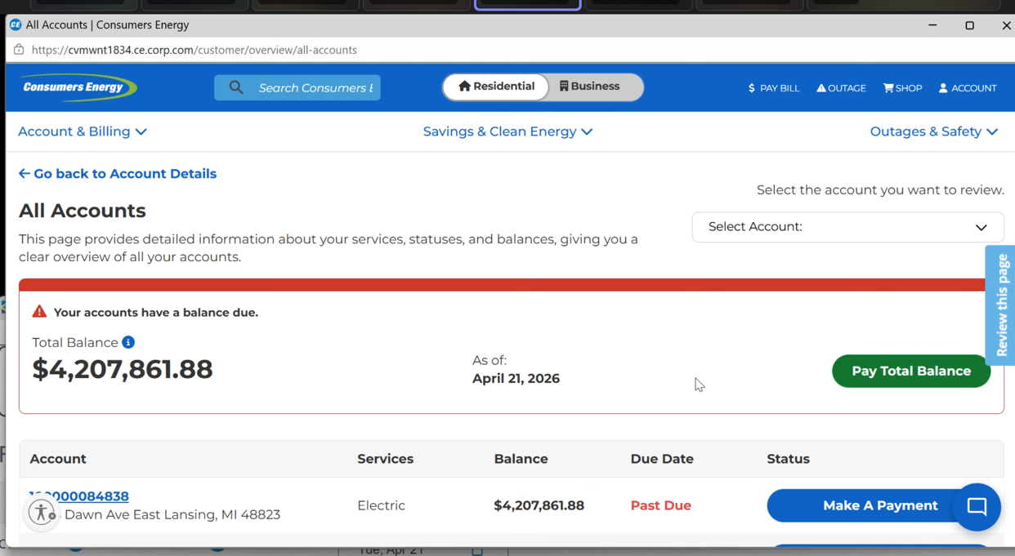

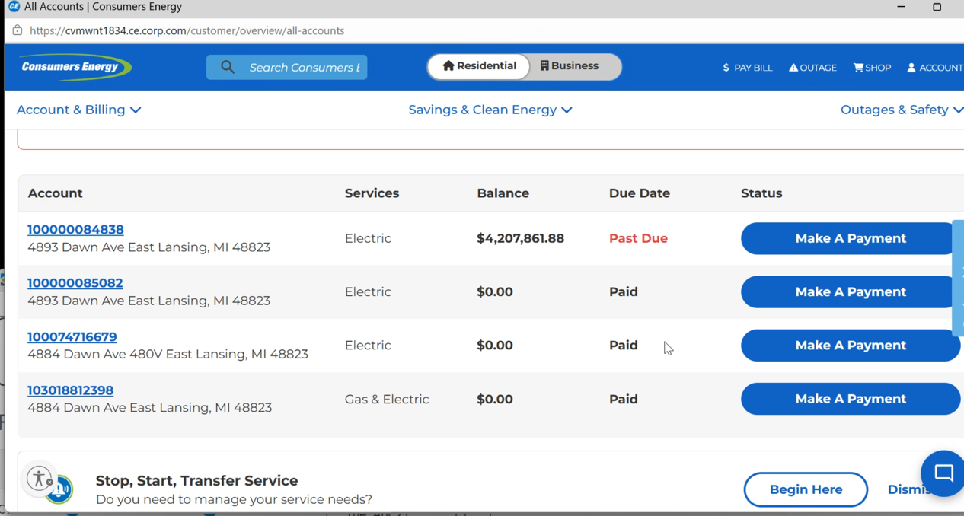

Is this used on a day to day basis???
Future: Need to make it more clear that this is view only

Web and digital Team will handle these changes

Hallmark removing

Riverstar – SSO
Inbound interface, River star to SAP

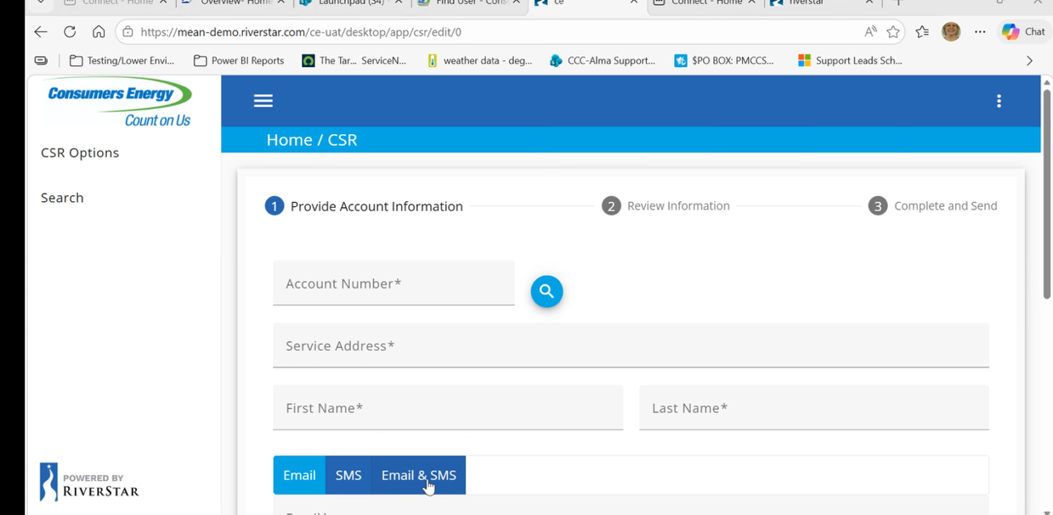

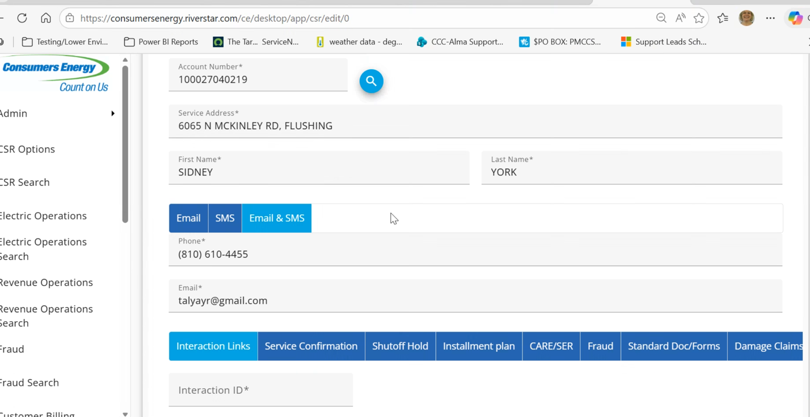

Connected with CRM
This is a Real Time API

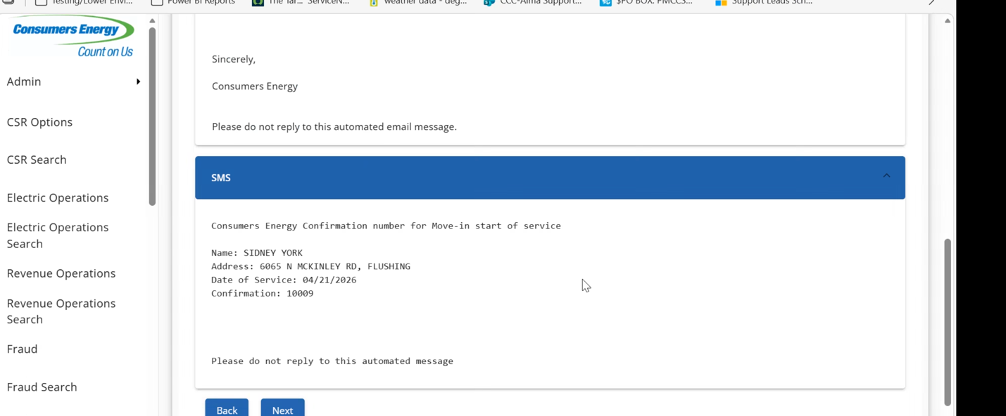

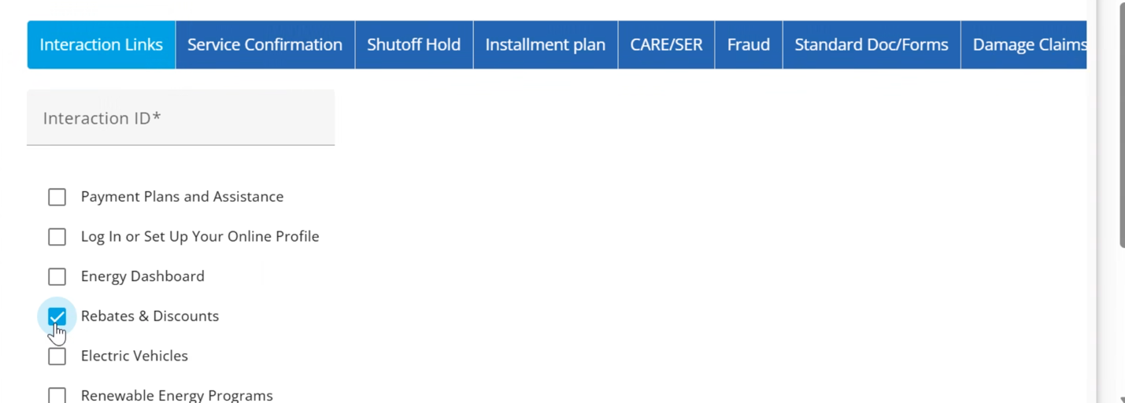

Copy Interaction ID from Riverstar to CRM

Option for Agent to use this for email problems with customer

Instant email or SMS

Input information to populate to the template

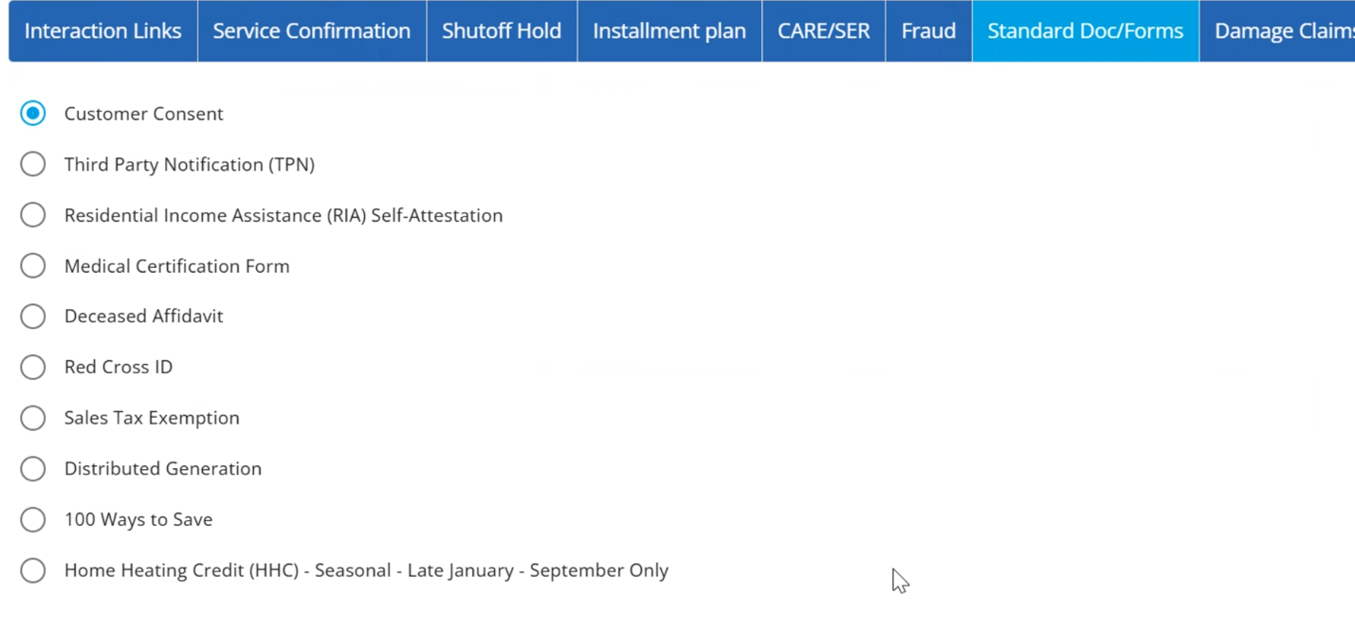
RIDA
CRM View with this same Drop down form, but CRM Can’t do text.
Need to decide where we are going to have all of the forms

Integration links in CRM will remain the same in Service cloud

Riverstar-emails and SMS, just outbound, no inboud
just did an integration with Service Suite

ERMS – email response management system

Customers do not reach Consumers Directly via email

Create Bill / Invoice
Not doing this future state

Switch Docs not used by CSR, but by some backoffice people
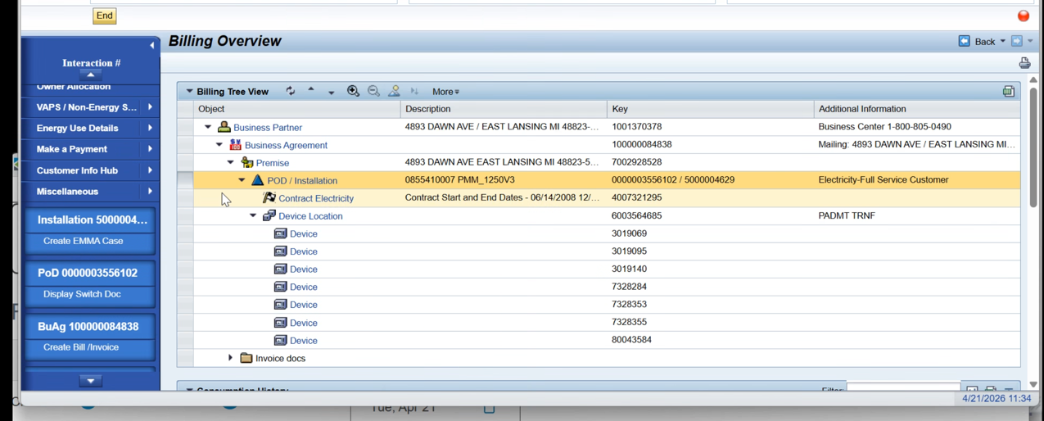

Get that customer overview from the factsheet

GCC or ECC Enrollment No
Blocks on suppliers yes

EMMA Case
Just 1 emma case can be initiated from front end

Org Structure in CRM cross-functional with P&C
Emma Cases, Refunds, how they’re going to get this back into SAP

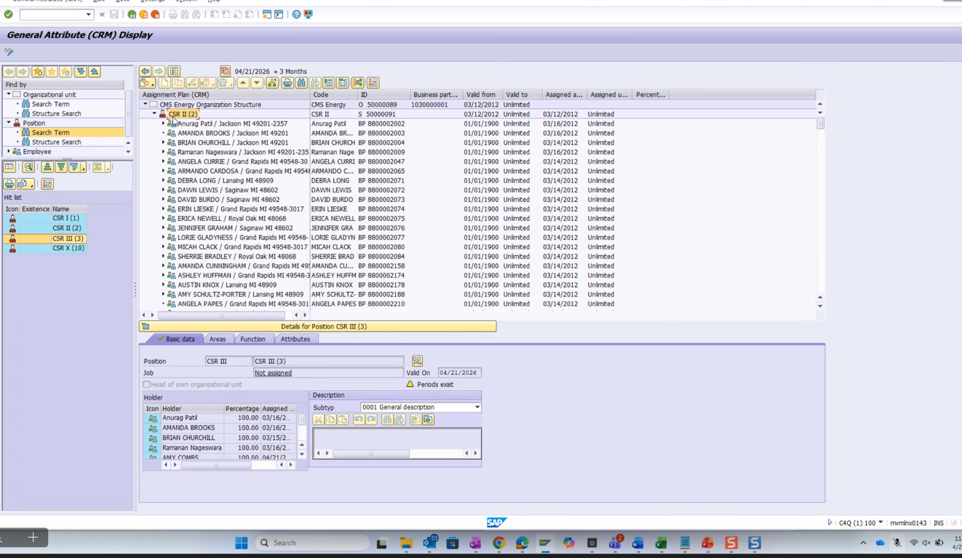

Nothing indicated which call center Certain CSRs are assigned to, in ECC for EMMAs you can see who their manager is, then that will be in sucessfactors which feeds into ECC

Agents can only pay to paymentus on behalf of the customer

Initiate Meter Pings
Greyed out, only smart meters

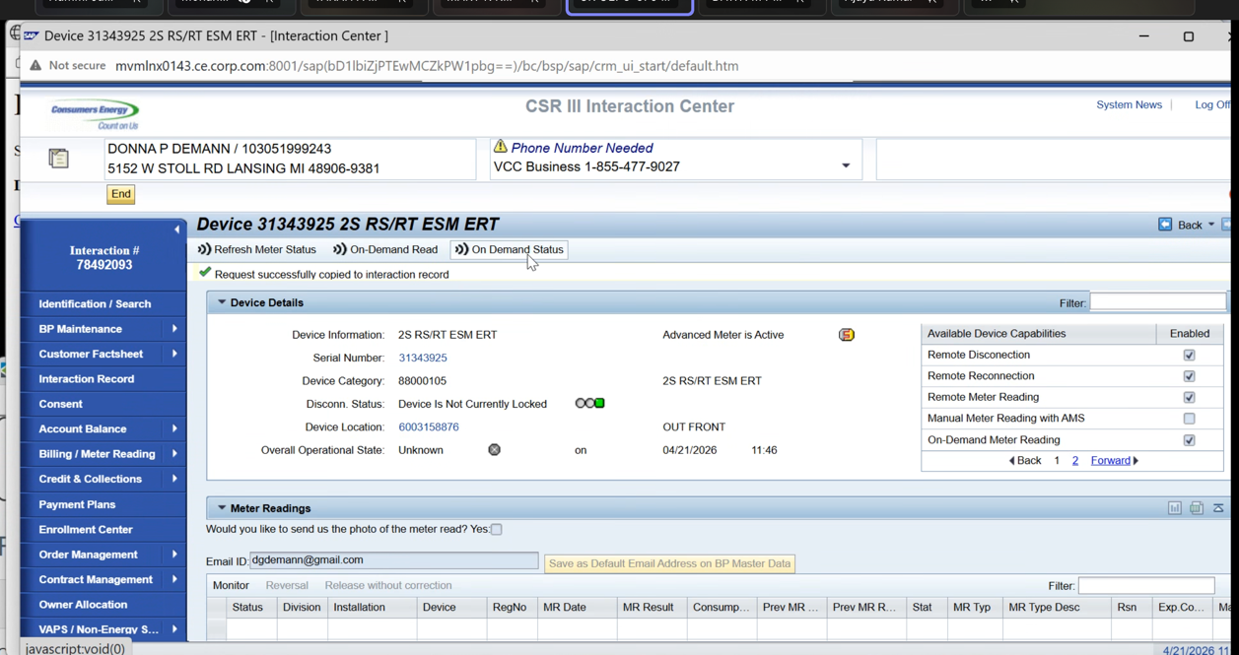

Standard Screen
Only customization – the little logo next to AMI logo

BOS – not SAP

SPLAT –

CRM Folder Only - Master Object List

Key Decisions/ Outcomes :
Need Decision – Build App or S/4 for Creating Service Order
Service Notification Key Decision

RIDA For all outside links

Notes are being stored in GUI at the table level and translation will have to take place (5 standard tables in CRM)

Add to RIDA List – migrate over from CRM to Service Cloud Directly Interaction records
What else? 6 years of data being migrated

Contract Management, Owner Allocation, (add Screenshot from BPML)

Display Service Notification: Elec Investigation
Where are we going to build to logic / where the work will reside
Main Work Center populated based on the notification

Riverstar CSR sending emails directly to customer
As of now no inbound / outbound emils

Inbound / outbound emails Key Decision

RIDA
CRM View with this same Drop down form, but CRM Can’t do text.
Need to decide where we are going to have all of the forms

Org Structure in CRM cross-functional with P&C
Emma Cases, Refunds, how they’re going to get this back into SAP

Parking Lot
Future Service Cloud Design: Need to look at each role separately to see what screens will show

WRICEF
8mil in KAN1
7.1 in BUT
Everything missing in BUT will be created in KAN1

Tara and Jose need to search an account w multiple accounts in CRM to translate that to Service Cloud
Link to Service Cloud V2 Rida Tracker:
RIDA Tracker for Service Cloud V2.xlsx
I’ve started making this as we’ve been “loosely” discussing RIDAs so we have a strong point to start from when we create them in ADO
Action Items |  |  | Person Responsible |  | Deadline
Customer Preferred Relight Data from Tara |  |  | Taylor get documentation from Tara |  | Workshop A  5.6.26
Cross Check in S/4 ECC Service Order Notification to have prepared for WAM integration sprint call tomorrow 671197 |  |  | Balajit |  | WAM Integration Call on Wednesday 4.22.26
Mapping the questions to each order CRM Order Management need decision on best Approach |  |  | Dawn, Tara, Jose |  | Workshop B  6.2.26
CVI additional Notes (Link in BPML  CRM BPM_Template_Latest04072026.xlsx |  |  | Taylor |  | Done
Uperform preference center |  |  | Jose follow up with Michelle |  | Workshop A  5.6.26
Need to revisit SME list for V2 Workshops (Need to ensure our audience is comprehensive of all perspectives so we are getting all necessary inputs |  |  | Tara, Dawn, Mary |  | Workshop A  5.6.26
Verify if devices are an object that can replicate to V2 |  |  | Jose |  | Workshop B  5.6.26
Jose look again at the mitigation plan for RIDA 671197 , need to determine with WAM Team whether or not it is a Risk |  |  | Jose |  | Workshop A  5.6.26

